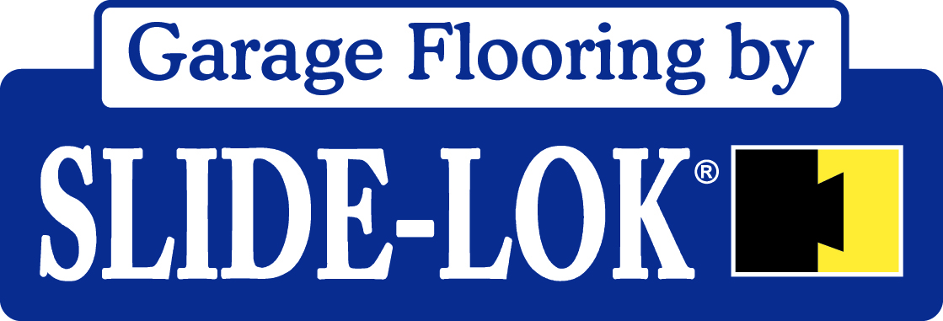

Polyaspartic Technical Data Sheet

Description:
A two component system. 75% solids. High gloss, non-flammable. Non-hazardous. ZERO VOC. We use VOC exempt solvents. This is a fast drying system. Very low to no noticeable odor! Designed specifically to apply as a decorative concrete coating. Can be applied in a wide range of temperatures and exhibits excellent abrasion, UV, and chemical resistant properties.

Typical Properties:

Appearance Clear Liquid
Total Solids (% by weight) 75
Total Solids (% by volume) 75
Ratio 1 to 1
Surface tension, dynes/cm 40
Viscosity (Brookfield LVF) 600
CPS @ 25 C 8.32
Specific Gravity 1.0
Flash point <70
Freeze/thaw stability N/A
Thermal stability
(28 days 52 C) No effect
Mechanical stability Good
V.O.C. (g/l) 90
Tg © 66

Free Film Properties:

Tensile strength (ASTM D 412) 7000
Elongation 10

Application Method: Roll, brush or Spray (airless or conventional). Note. Dilute product with solvent (acetone, MEK, or Xylene) as needed for particular type of spayer you are using. 10 mil wet yields 7.5 mil DFT

Application Properties of Film:

Dry time @ 25 (c) 30
Dry to touch 60-90
Dry through 120-240

QUV weatherometer (alclad aluminum 1000 hours)

Oxidation No effect
Loss of gloss Slight
Blistering No effect
Yellowing No effect

Adhesion results

Tensile Adhesion 900 psi
(ASTM 4541)
Applied to concrete with primer
At 900 psi the concrete failed.

Physical Performance Properties of Dry Film:

All tests were conducted on 5.0 mil films, air-dried for 7 days at ambient temperature.

Hardness
a) Pencil 2H
b) Sward 70
Taber abrasion (ASTM D 4060) 36 mg
Impact resistance (ASTM D 2794)>160

Chemical Resistance (ASTM D 1308)
Gasoline No effect
Brake Fluid No effect
Antifreeze No effect
Transmission Fluid No effect
Power Steering Fluid No effect
MEK 400 rubs
Acetone 400 rubs
IPA 400 rubs
Formula 409 400 rubs

Uses:
- May be used as a high level, industrial strength polyaspartic topcoat over properly prepared and primed aluminum, carbon steel, galvanized, concrete and cinderblock
Where:
- Long term color retention is desired
- Long term gloss retention is desired
- Low environmental footprint is desired
- Product can be applied either by brush, roller or spray
- Outstanding chemical resistance
- Excellent flexibility is needed
- Fast dry times are important

Not recommended for:
- Immersion Service

Compatibility with other coatings:
- Slide-Lok polyaspartic can be re-coated with itself following a surface prep. Using an abrasion pad (contact Slide-Lok for recommendation) rough up the surface of the desired area to be re-coated and wipe clean with acetone.

- Slide-Loks polyaspartic bonds well with other polymers with proper surface preparation. Consult Slide-Lok with previous coating specs for details.

- Slide-Lok polyaspartic may be used over most aged and hard-cured coatings in good condition with proper preparation and abrading. Testing for lifting, bubbling and adhesion is recommended to assure compatibility with unknown coatings. Contact Slide-Lok representatives for specific recommendations.

Maximum Service Temperature:
- 250F (93C)

Color:
- Slide-Lok polyaspartic is a solvent based component which can be mixed with any 844 solvent based pigment color.

Packaging:
- Slide-Lok packages its products in either a six (6) gallon kit consisting of three (3) gallons of catylist and three (3) gallons of polyl or a two (2) gallon kit consisting of one (1) gallon of catylist and one (1) gallon of polyl. Unless specified and agreed on by Slide-Lok representatives all product is shipped to the customer clear, and a pigment is provided which can be mixed in for proper coloring effect.
Shipping Weight:
- Six gallon kit weighs 60 pounds
- One gallon kit weighs 9.5 pounds
- One quart of pigment 2 pounds

Shelf Life and storage Conditions:
- Store in a dry, well-ventilated area. Storage conditions should be between 35F and 120F
Shelf Life:
- Twelve (12 months minimum.

Theoretical Coverage Per Gallon:
- 250 ft sq @ 1 mil (Prime Coat)
- 350 ft sq @ 5 mil (Color Coat)
- 250 ft sq @ 5 mil (Top Coat)

Suggested film Builds:
*See attached spread rate chart

Surface Preparation:
- Let new concrete age for 28 days before preparing surface and applying coating. Slide-Lok recommends the use of a diamond grinder for dry mechanical preparation of surface.
- If acid etching contact Slide-Lok for recommended procedures.
- Newly primed surfaces should be clean and dry. If contaminated, detergent/water wash, then blow dry. Previously painted surfaces should have all loose paint removed and the edges feathered. Prime bare spots with appropriate primer.

Activation:
- See Slide-Lok mixing instructions

Reduction:
- 25 to 40 ounces of acetone (urethane grade only) will reduce the product to roughly 60% +/- 2% solids content.

- 16-25 ounces of acetone (urethane grade only) will reduce the product to roughly 65% +/- 2% solids content.

- 4-8 ounces of acetone (urethane grade only) will reduce the product to 70% +/- 2% solids content.

- If faster recoat and handling are required mix in Slide-Lok’s accelerator product at intervals of 2 ounces until desired speed is achieved do not exceed more than 16 ounces of accelerator per gallon.

Application Thinners:
- A urethane grade acetone that contains no more than 1/10th of 1% water by volume is recommended.

Application Conditions:
- Do not apply if the application surface is wet or if the surface temperature is below 20F or exceeds 150F

Application Equipment:
- Apply by either spray brush or roller
Spray:
- See List below

Roll:
- Manufacturer Wooster 3/8 tight nap roller (white)

Additions:
- Add either 4, 8, 16, 25, or 40 ounces of acetone to eliminate bubbles and roller lines. Slide-Lok recommends cross rolling to reduce roller lines. See mixing instructions for recommended amounts of acetone.

- For best results allow 2 minutes of mix time.

